Timeline: Major Deadlines
W, 1/13 Bring a printed copy of the article of your choosing
W, 1/20 Half Draft, Project 1 Due (at least 2 drawings + 2 accounts)
Submit to Google Drive and bring one hard copy to class
W, 1/27 Final draft (and Invention Portfolio) due to Google Drive

Assignment Description
One effective way to begin researched writing is with a careful examination of sources. For our first project, we will inquire into the “resourcefulness of sources.” That is, we will do something that students in first year writing classes don't often do: we will examine one source from several perspectives to see how it is a part of a larger dialogue. With our “worknets,” we will begin to become comfortable with sustained inquiry as part of the research process. We will look into the many ways one source can provide us direction in our process of invention and composition.

You will create four worknets for this project, bibliographic, semantic, affinity-based, and choric, and do a piece of writing about each one. (Don't let this vocabulary scare you. All of these words will be defined in class.) You will base your worknets on an article of your choosing. I have preselected articles that you may choose from. If you’d prefer to pursue another piece of scholarly literature, we can discuss that via email, but your decision must be firm by Wednesday, January 13.

Each worknet will consist of a link-and-node sketch done either in Google Docs, another computer program, or (very neatly) by hand. I’ve included examples of a link-and-node sketch on the last page of this assignment sheet. With your sketch, you will visually map your discoveries as you examine your source from each new perspective.

Each worknet will be accompanied by a one-page account (about 400 words) that explains your discoveries in a detailed way for your research process. In your written accounts, you will answer the following questions in a detailed, thoughtful way, describing your discoveries and the twists and turns of your process:
- Bibliographic Worknet: How is this author's work connected to other authors' work through his/her use of sources? What did I learn by looking at at least three of the sources this author used?
- Semantic Worknet: How does this author repeat certain words/phrases? How are these words/phrases connected to important ideas or concepts that a researcher could investigate? What discoveries did I make by researching these words/concepts?
- Affinity-Based Worknet: Can I find out anything about this author's professional network? (If not, describe your research process anyway and the roadblocks you encountered.) How do his/her affiliations with other professionals give me perspective on the information being offered or the claim/argument he/she is making?
- Choric Worknet: How can I think about this author's article as part of a particular cultural moment? For example, if it was published in the United States in 1985, what events or circumstances might have had an influence on the author? (It is okay if this section is a bit speculative; choric worknets are meant to be generative, to provide you with interesting juxtapositions.)

Getting Started
The term “worknet” is meant to get you thinking about the “work” aspect of an author's writing, to help you imagine a writer's patterns of activity and consider the many hours that are often spent generating an article. The “net” part is a way to encourage you to think about connections, to inspire the question: What connections can I make between this work and other work, other ideas? Looking at researched writing as a process, rather than as a product, will serve you as you fulfill the requirements of this project.

Style Conventions
Your project should be 8 pages long (4 pages of text + 4 worknet illustrations). Papers should be typed, double-spaced, with 12-pt Times New Roman font. Use MLA style and formatting, including in-text citation and a Works Cited list. For additional information about using MLA, please refer to chapter 49 of Writing in Action or the OWL of Purdue website linked in our website as a resource.

Grading Criteria
- Drawing Detail: Link-and-node drawings are detailed and show understanding of the purpose of each type of worknet
- Evidence of Research: Written accounts show evidence of a rigorous research process, are thoughtfully written, and show understanding of the purpose of each type of worknet
- Development: Your project should feel complete. You should, as concisely as possible, show evidence of thoughtful inquiry into your chosen article.
- Arrangement: Your project should be arranged as a cohesive piece of text—that is, it should be organized in a way that allows your reader to easily navigate your writing. I encourage you to be creative with headings, subheadings, and other organizational strategies to compose an engaging essay.
- Correctness: Your essay should be proofread for spelling, capitalization, and syntax errors. Reading aloud can help you catch these errors, as well as repeated phrases and unfinished sentences.

Rubric
 | NA | NI | AC | EX
Drawing Detail
Evidence of Research
Development
Arrangement
Correctness
Invention Portfolio
Participation

EX: Exceptional. The writer has applied the criterion with distinction.
AC: Acceptable/Meets Expectations. The writer has applied the criterion to an acceptable degree.
NI: Needs improvement. The writer has minimally applied the criterion in the project.
NA: Narrowly applied or not applied. The writer has not applied the criterion in the project.

Example of a Link-and-Node Sketch
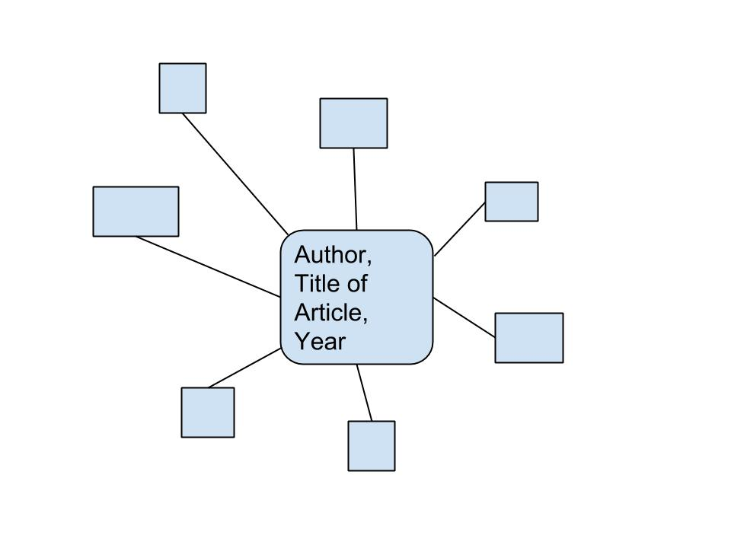
Example of a Worknets Link-and-Node Sketch (Semantic)
